**COMSATS University Islamabad, Islamabad campus**

**Department of Computer Science**

**CLASS ASSIGNMENT #4**

**FALL 2021**

Answer to all questions must be submitted in MS Word.  
Answer to all questions should begin on new page.  
Assignment document must contain a title page showing Assignment-1, your name and  
registration number.  
Assignment document must also contain JAVA source code (For JAVA Programming Questions)  
along with output.  
Solution to JAVA Programming problems must be created in separate .java file (for each  
question). For example, Question1.java  
You must follow proper JAVA naming convention for identifiers and properly document your  
source code  
Combine all your work in one folder. The folder must contain .JAVA source files (for JAVA  
Programming Questions) and a .doc/.docx file.  
Name of the Assignment document file should be your Registration Number. E.g.  
FA21BCS01.docx  
Submit your work via MS Teams

**QUESTION #1 (CLO-3)**

Write a Java program to keep accepting 10 integer values from user until valid values are entered. If the user enters invalid integer values then ask the user to enter it again. For example if the given input is as below…

11

2

99

21abc

Then your program should ask the user to enter the fourth value again as it is invalid.**User should not be asked to enter the valid values again.**

Once all the values are entered then sort these values in ascending order.

**QUESTION #2 (CLO-3)**

Write a method that returns the sum of all the elements in a specified column in a matrix using the following header:

**public static double sumColumn(double[][] m, int columnIndex)**

Write a test program that reads a 3-by-4 matrix and displays the sum of each

column. Here is a sample run:

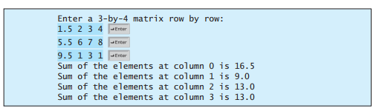

**QUESTION #3 (CLO-3)**

Write a method that sums all the numbers in the major diagonal in an n * n matrix of double values using the following header:

**public static double sumMajorDiagonal(double[][] m)**

Write a test program that reads a 4-by-4 matrix and displays the sum of all its elements on the major diagonal. Here is a sample run:

